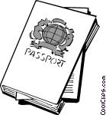
Sixth Grade
Social Studies
FINAL PROJECT:
Ancient World History Passport
Important Project Information

PROJECT DESCRIPTION:

As a culminating activity to your study of Ancient World History, you will design an Ancient World History passport. You will create a page/entry for each civilization that we have “visited” at length this year (Mesopotamia; Egypt; Greece; and Rome). You have the option of earning additional points by making a page for one of the civilizations that we spent less time on (Israel; India; or China).

On each passport page, the following information MUST be included: the name of the civilization; a picture of the civilization; a map of the civilization; three facts about the civilization; two notable people encountered in the civilization; and two notable places encountered in the civilization. You will emboss the bottom of each page with a “stamp” of some kind, indicating that you have visited the said destination.

You may design and bind the passport in whatever way you choose. Please be sure to take your time and write legibly. All illustrations should be neat and professional-looking. Both computer-generated AND self-made/hand-drawn are acceptable.

Substantial class time will be given for working on the project during the week of May 21st, but certain aspects should be fine-tuned and completed at home. The project will be due on Friday, May 25th and students will participate in a Gallery Walk activity on that day. Projects will be displayed and students will thoughtfully and constructively critique each others’ work.
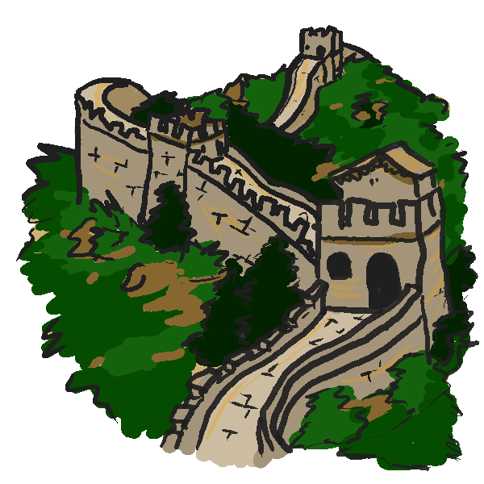

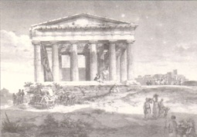
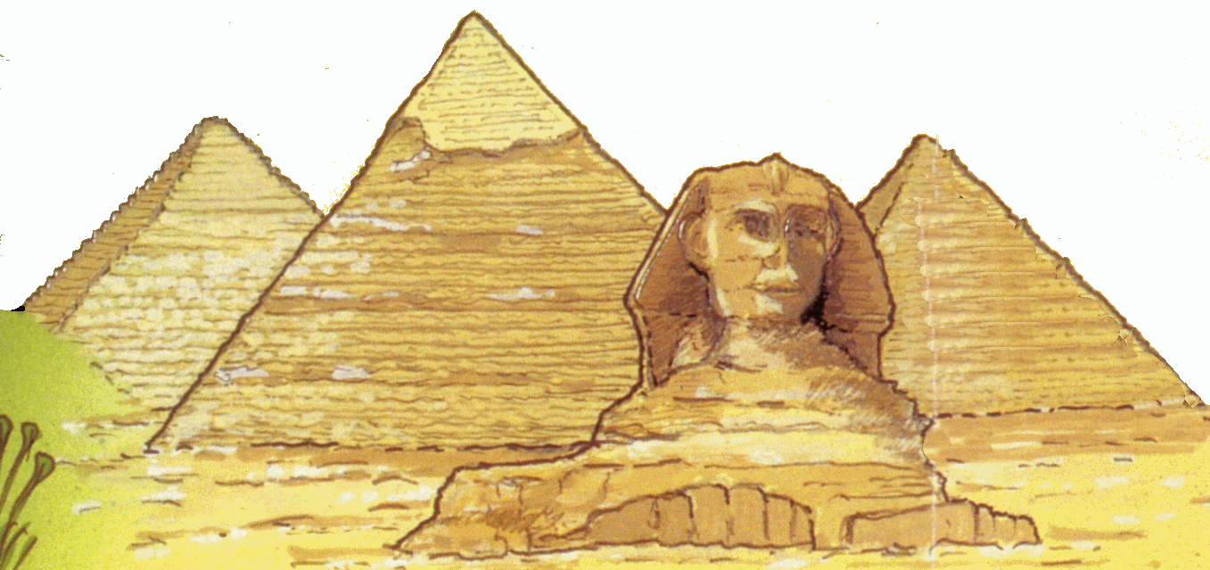

PROJECT REQUIREMENTS/ POINT VALUES:
Project Requirement/Description | CCS & NGSSS  Assessed/  Demonstrated | Point Value
Destination One: Mesopotamia  - Name of Civilization  - Picture/Illustration of Civilization (either computer or self-generated)  - Map of Civilization (either computer or self-generated)  - Three Facts About The Civilization  - Two Notable People Encountered in this Civilization  - Two Notable Places Encountered in this Civilization  - “Stamp” indicating destination visited | CCSS.ELA-LITERACY.RH.6-8.1—Cite specific textual evidence to support analysis of primary and secondary sources.  CCSS.ELA-LITERACY.RH.6-8.7—Integrate visual information (e.g., in charts, graphs, photographs, videos, or maps) with other information in print and digital texts.  SS.6.W.2.3—Identify the characteristics of civilization.  SS.6.W.2.4—Compare the economic, political, social, and religious institutions of ancient river civilizations.  SS.6.W.2.7—Summarize the important achievements of Mesopotamian civilization.  SS.6.W.2.8—Determine the impact of key figures from ancient Mesopotamian civilizations.  SS.6.G.1.7—Use maps to identify characteristics and boundaries of ancient civilizations that have shaped the world today.  SS.6.G.2.4—Explain how the geographical location of ancient civilizations contributed to the culture and politics of those societies. | 15 Points
Destination Two: Ancient Egypt  - Name of Civilization  - Picture/Illustration of Civilization (either computer or self-generated)  - Map of Civilization (either computer or self-generated)  - Three Facts About The Civilization  - Two Notable People Encountered in this Civilization  - Two Notable Places Encountered in this Civilization  - “Stamp” indicating destination visited | CCSS.ELA-LITERACY.RH.6-8.1—Cite specific textual evidence to support analysis of primary and secondary sources.  CCSS.ELA-LITERACY.RH.6-8.7—Integrate visual information (e.g., in charts, graphs, photographs, videos, or maps) with other information in print and digital texts.  SS.6.W.2.3—Identify the characteristics of civilization.  SS.6.W.2.4—Compare the economic, political, social, and religious institutions of ancient river civilizations.  SS.6.W.2.5—Summarize important achievements of Egyptian civilization.  SS.6.W.2.6—Determine the contributions of key figures from ancient Egypt.  SS.6.G.1.7—Use maps to identify characteristics and boundaries of ancient civilizations that have shaped the world today. | 15 Points
Destination Three: Ancient Greece  - Name of Civilization  - Picture/Illustration of Civilization (either computer or self-generated)  - Map of Civilization (either computer or self-generated)  - Three Facts About The Civilization  - Two Notable People Encountered in this Civilization  - Two Notable Places Encountered in this Civilization  - “Stamp” indicating destination visited | CCSS.ELA-LITERACY.RH.6-8.1—Cite specific textual evidence to support analysis of primary and secondary sources.  CCSS.ELA-LITERACY.RH.6-8.7—Integrate visual information (e.g., in charts, graphs, photographs, videos, or maps) with other information in print and digital texts.  SS.6.W.2.3—Identify the characteristics of civilization.  SS.6.W.3.5—Summarize the important achievements and contributions of ancient Greek civilization  SS.6.W.3.6—Determine the impact of key figures from ancient Greece  SS.6.G.1.7—Use maps to identify characteristics and boundaries of ancient civilizations that have shaped the world today.  SS.6.G.2.4—Explain how the geographical location of ancient civilizations contributed to the culture | 15 Points
Destination Four: Ancient Rome  - Name of Civilization  - Picture/Illustration of Civilization (either computer or self-generated)  - Map of Civilization (either computer or self-generated)  - Three Facts About The Civilization  - Two Notable People Encountered in this Civilization  - Two Notable Places Encountered in this Civilization  - “Stamp” indicating destination visited | CCSS.ELA-LITERACY.RH.6-8.1—Cite specific textual evidence to support analysis of primary and secondary sources.  CCSS.ELA-LITERACY.RH.6-8.7—Integrate visual information (e.g., in charts, graphs, photographs, videos, or maps) with other information in print and digital texts.  SS.6.W.2.3—Identify the characteristics of civilization.  SS.6.W.3.8—Determine the impact of significant figures associated with ancient Rome.  SS.6.W.3.14—Describe the key achievements and contributions of Roman civilization.  SS.6.G.1.7—Use maps to identify characteristics and boundaries of ancient civilizations that have shaped the world today.  SS.6.G.2.4—Explain how the geographical location of ancient civilizations contributed to the culture and politics of those societies. | 15 Points
Ancient World History Passport Cover Page  - Title of Your Project (ie. “My Ancient World History Passport”)  - A Picture/Illustration  - Your Name, Period, and Date in the Bottom Right Corner | (no CCS or NGSSS assessed/demonstrated) | 10 Points
Quality/Neatness of the Final Project  - The project is neat, legible, and of a professional quality.  - Time and effort are evident.  - The contents of the project are bound and assembled into a book of some kind.  - Project is turned in on time (Friday, May 25th) | (no CCS or NGSSS assessed/demonstrated) | 30 Points
 |  | 100 Points

