Name ________________________________________ Period ____ Date ______________

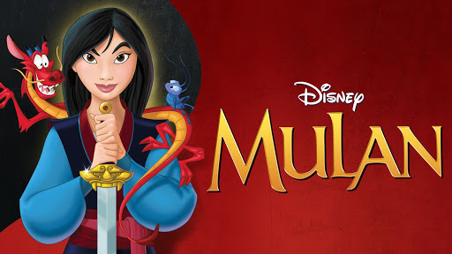
Sixth Grade
Social Studies
Secondary Source Analysis Worksheet
Disney Presents:
Mulan

PART I. HISTORICAL ACCURACIES V. INACCURACIES CHART
Directions: As you watch Disney’s Mulan, observe the ways in which ancient Chinese life is portrayed. When you see an aspect of Chinese life (e.g. clothing styles; religious beliefs; gender dynamics; daily activities) that is portrayed accurately, mark it in the “historical accuracies” box. When you see an aspect of Chinese life that is NOT portrayed accurately, mark in it the “historical inaccuracies” box. You do NOT need to write in complete sentences; phrases or bullet points are fine.

HISTORICAL ACCURACIES | HISTORICAL INACCURACIES

PART II. EXTENDED RESPONSE
Directions: Answer the following questions in a complete sentence or more. Be sure to support your answer with evidence.

1. Do you think that a movie like this is a useful secondary source? Why or why not?

2. How is Disney’s Mulan similar to the “Ballad of Mulan”? How are they different?

